**The "Battle" of Neighborhoods: Manhattan vs Staten Island**

**Introduction**

The world has faced a new challenge - to resist to new coronavirus COVID 19. The virus has penetrated all countries. The greatest threat of contamination to the inhabitants of megacities.

While scientists are looking for a vaccine, and doctors are fighting for people 's lives, our task is **KEEP CALM, STAY HOME** .

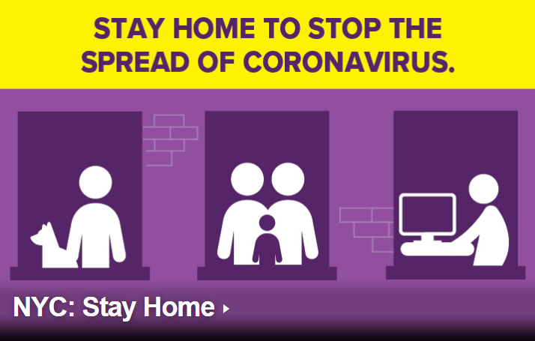

New York city is heroic against the virus. Unfortunately, it 's not stopped yet. You can find daily updates of information about people who have tested positive for COVID-19 in NYC:

<https://www1.nyc.gov/site/doh/covid/covid-19-data.page>

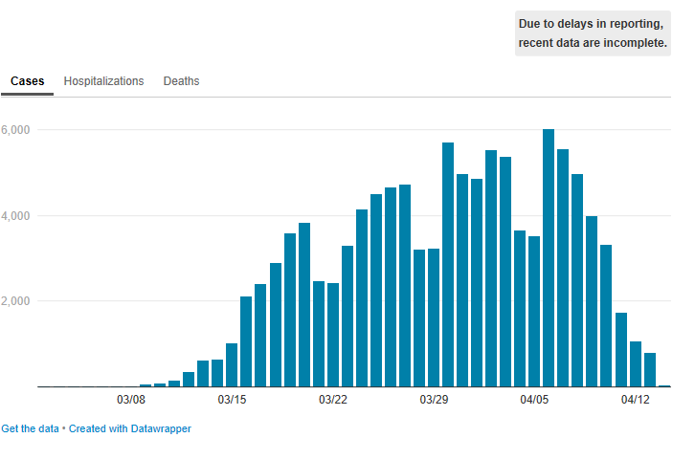

Due to the coronavirus outbreak, all of NYC’s nonessential businesses have been ordered to keep their workforces at home, and all nonessential gatherings are temporarily banned.

**Residents Manhattan** began to search for housing in other parts of the city. They no longer need restaurants and places of entertainment, they need places for privacy and relaxation.

NYC has 5 Boroughs :

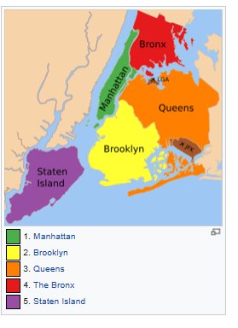<https://www.nycgo.com/neighborhoods-boroughs/about-nyc-five-boroughs/> .

* Bronx,
* Brooklyn,
* Manhattan,
* Queens
* Staten Island.

<https://en.wikipedia.org/wiki/Boroughs_of_New_York_City>

Bronx, Brooklyn and Queens have a high count of diseases:

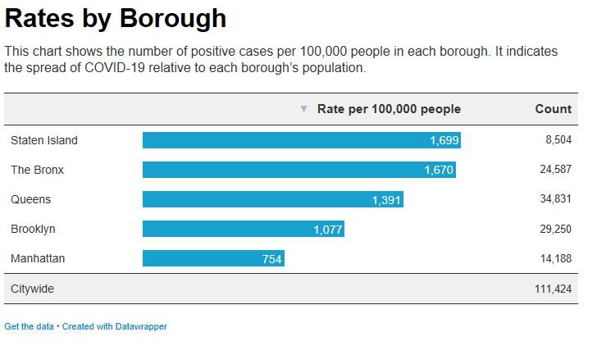

Let's have a look at **Staten Island**.

Easily accessible by a scenic ride on the Staten Island Ferry, the greenest borough feels like a getaway within the City. Beyond a charming North Shore rich with maritime history, Staten Island is best known for its beaches, vast parkland and even a fully preserved colonial village.

**Real Estate Agency** (hereinafter referred to as “REA”) would like to compare those two Boroughs (Manhattan vs Staten Island) and to focus on a list of places of Basic necessities: hospitals, pharmacies, food stores, repair workshops, veterinary clinics and so on. The full list of Basic necessities is provided here : <https://esd.ny.gov/guidance-executive-order-2026?cid=NYCEM_MEM_Coronavirus11_20200320>

**Can REA offer to rent housing with all Basic necessities in Staten Island?**

**Data**

We will have a look at the list of Neighborhoods of each Boroughs and more focus on Manhattan and Staten Island. We use a dataset that contains the 5 boroughs and the neighborhoods that exist in each borough as well as the latitude and longitude coordinates of each neighborhood. Then we will select the places of Basic necessities, will group the neighborhoods into clusters and will visualize them with Folium library:

* <https://cocl.us/new_york_dataset>
* <https://geo.nyu.edu/catalog/nyu_2451_34572>
* Foursquare API to explore neighborhoods in NYC.

**Methodology**

All steps of solving are provided in 2 files:

* **Task3 NYC- Manhattan.ipynb**
* **Task3 NYC - Staten Island.ipynb**

I took Data and convert addresses into their equivalent latitude and longitude values. When I used the Foursquare API to explore neighborhoods in NYC. I focused on 2 Borough: Manhattan and Staten Island. Then I used the **explore** function to get the most common venue categories in each neighborhood, and then use this feature to group the neighborhoods into clusters.

Finally, I used the Folium library to visualize the neighborhoods in Manhattan and Staten Island and their emerging clusters.

**Results**

Now we have a list of Borough of NYC with total number of Neighborhoods and its visualization:

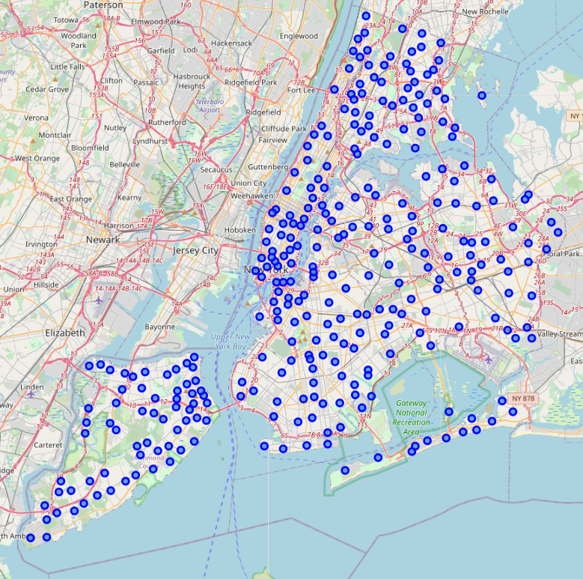

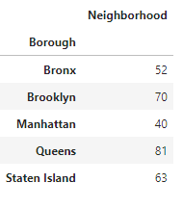

All Neighborhoods were clustered, and we can allow clients of REA to compare present situation (Manhattan) to the simulated one (Staten Island).

Manhattan:

REA client lives in Midttown .

Venues have 324 categories, but now people can’t make shopping in the big center or spend their time in restaurants, visit gym, exhibitions, concerts. We are forced to focus hospitals, pharmacies, food stores, repair workshops, veterinary clinics and so on .

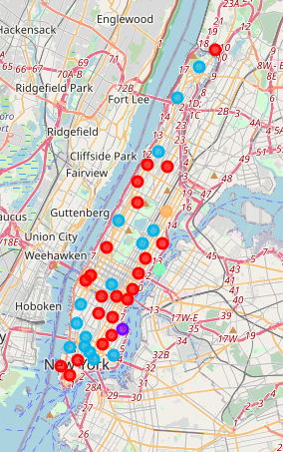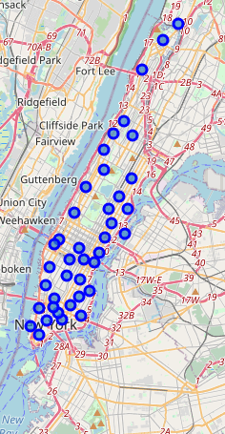

REA client selected "must have" items from 324 elements:

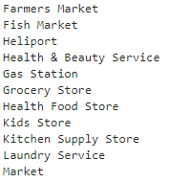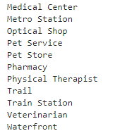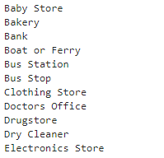

Now the client can see all venues, which are clustered according selected categories. **Now we visualized a situation “YOU HAVE”:**

* red dot – Cluster 1, the biggest one, has 22 neighborhoods
* purple dot - Cluster 2, has only 1 neighborhood
* blue dot - Cluster 3, has 15 neighborhoods, Midttown is included
* salat dot - Cluster 4, has only 1 neighborhood
* yellow dot Cluster 5, has only 1 neighborhood

Then we can discuss a simulated situation. REA client would like to move to Staten Island and would like to see all requested points.

Staten Island:

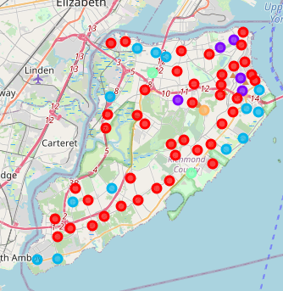

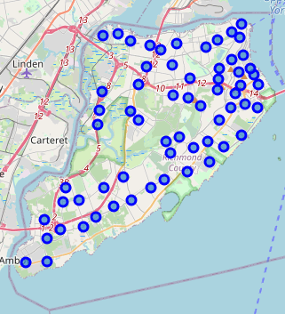

We were forced to correct a list of Basic necessities, because the list of Manhattan places doesn't match a list is Staten Island . Venues in Staten Island don’t have categories:

Pet Service, Baby Store, Veterinarian, Drugstore, Physical Therapist, Waterfront, 'Fish Market, Metro Station, Laundry Service, Health Food Store, Heliport, Medical Center, Kitchen Supply Store, Doctors Office

The new list of “MUST HAVE” looks like:

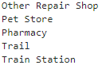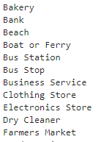 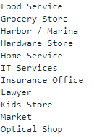

**Now we visualized a situation “COULD BE” :**

* red dot – Cluster 1, the biggest one, has 42 neighborhoods.

St.George venue is included. The client asked about it.

* purple dot - Cluster 2, has 5 neighborhoods
* blue dot - Cluster 3, has 13 neighborhoods
* salat dot - Cluster 4, has 2 neighborhoods
* yellow dot Cluster 5, has only 1 neighborhood

**Discussion**

Now REA is ready to discuss client’s request with a client and to compare 2 situation “YOU HAVE” and “COULD BE” ….

Moreover, REA can provide more information about each cluster and determine the discriminating venue categories that distinguish each cluster.

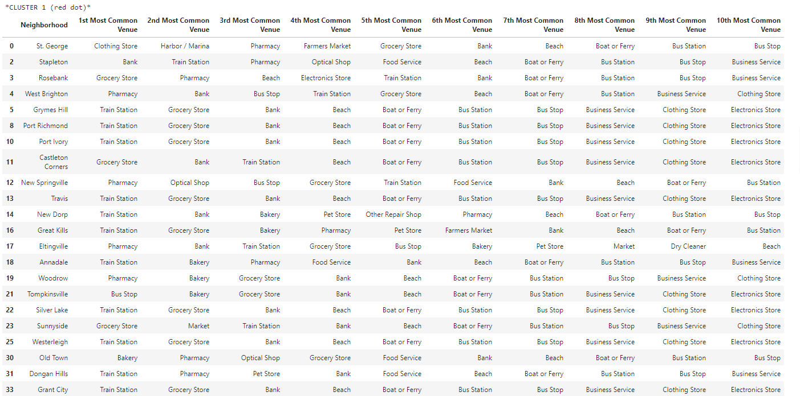

Now REA can give him a time for decision:

* to move to Staten Island
* to change living place in Manhattan
* to stay at home

But before it I would like to provide a map of positive COVID -19 according NYC Borough:

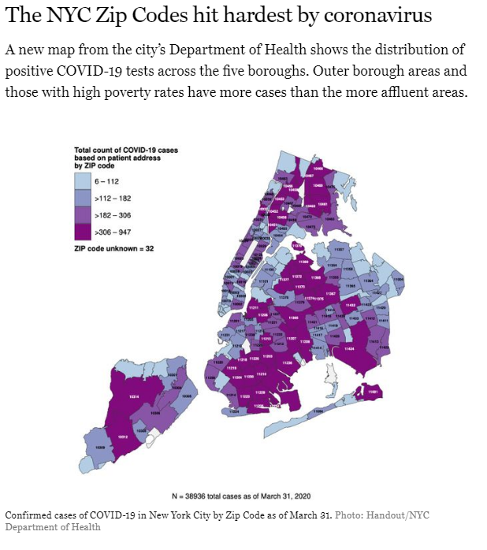[**https://nymag.com/intelligencer/article/new-york-coronavirus-cases-updates.html**](https://nymag.com/intelligencer/article/new-york-coronavirus-cases-updates.html)

**Conclusion**

I hope the provided report will help to make the best decision which allow to reach “WIN-WIN ” situation in cooperation REA with their clients